DATA LOADING IN SNOWFLAKE
COPY TRANSFORMATIONS

In order to understand copy transformations better, let’s do hands on
First let us create an external stage and copy data into a table from external file
Let’s take an example
Creating external stage pointing to files at AWS location
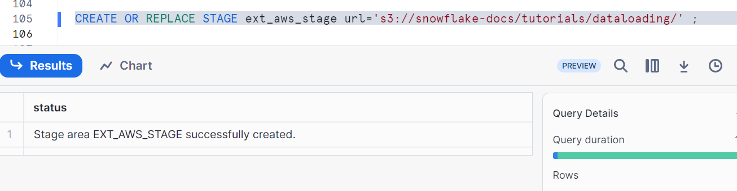
List the Stage. It shows the files
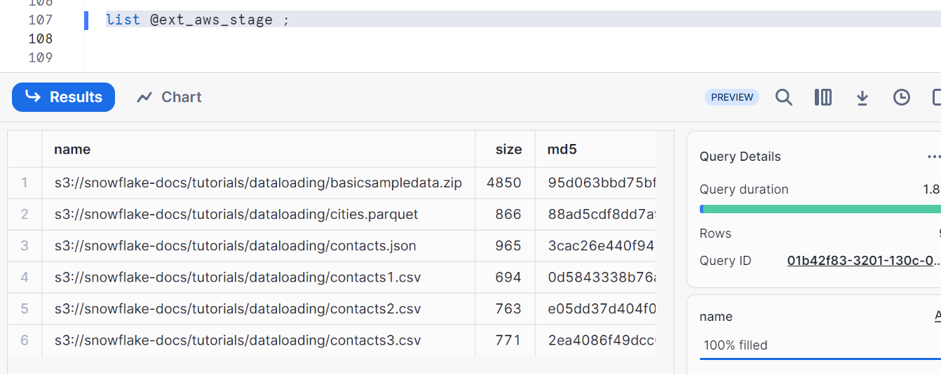
Create a table to load the files. The tables should have exact number of columns as file containing columns
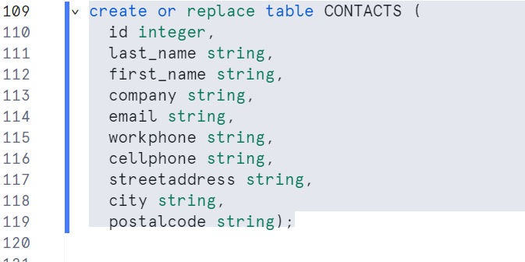
Copying file contacts5.csv into table and observe the data
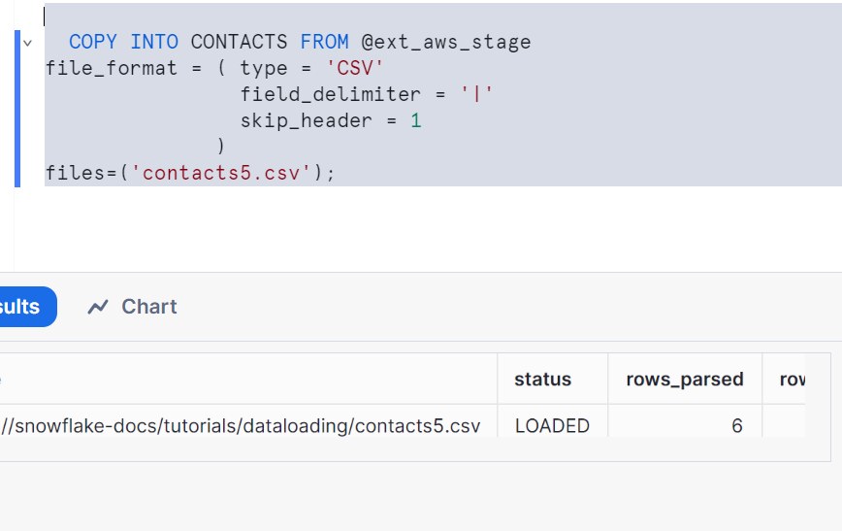
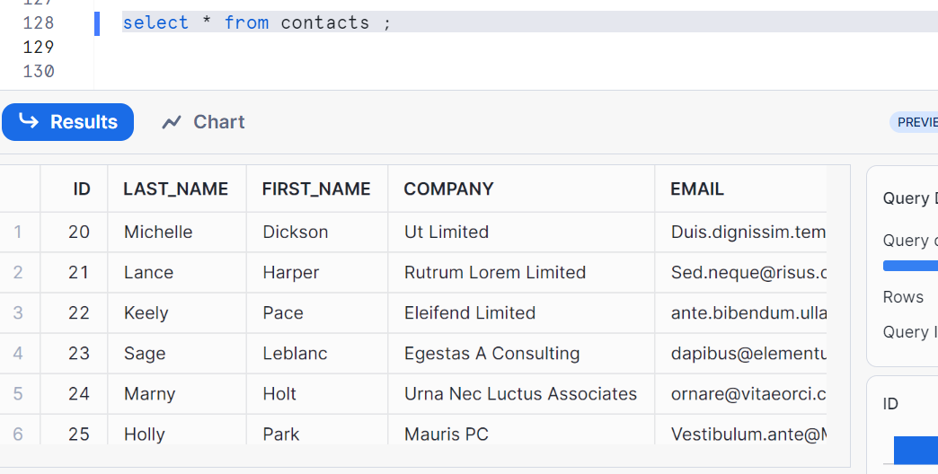
Now, let’s do some copy transformations
Case1: specific columns to table from the file
Create a table having different columns than stage. Hence File columns and table columns can be different
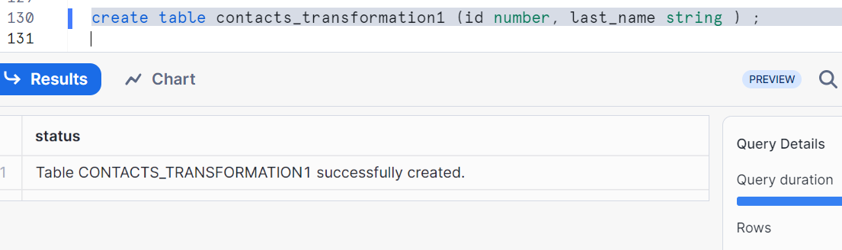

Now, let’s copy some specific columns to table from the file by following syntax
Note: always remember, the data present in external stage (@ext_aws_stage) is same as that of contacts table as we copied the data.
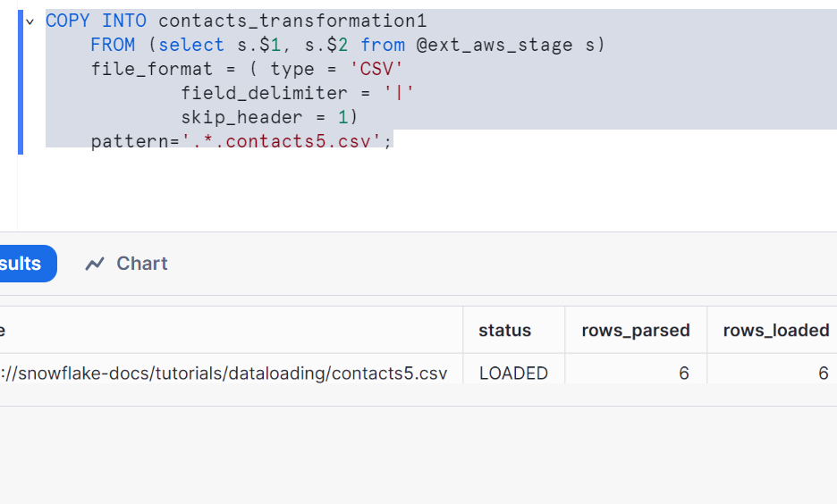
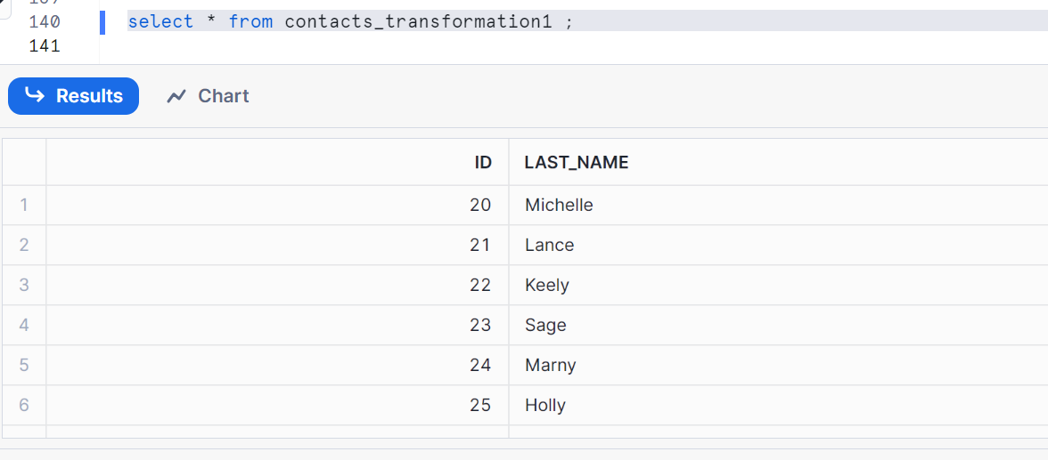
Now check contacts table with the output above
Case2: Column reordering
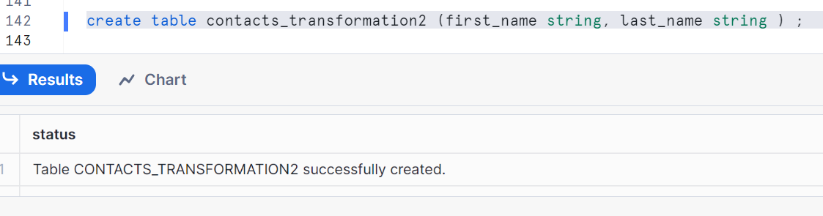
In select statement, I had given columns in the order 3 and 2 so that 3rd column records goes to first name and 2nd column records goes to last name
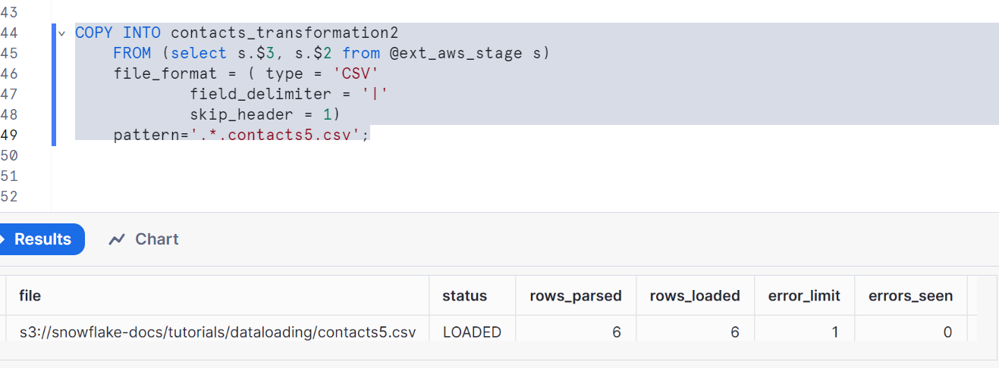
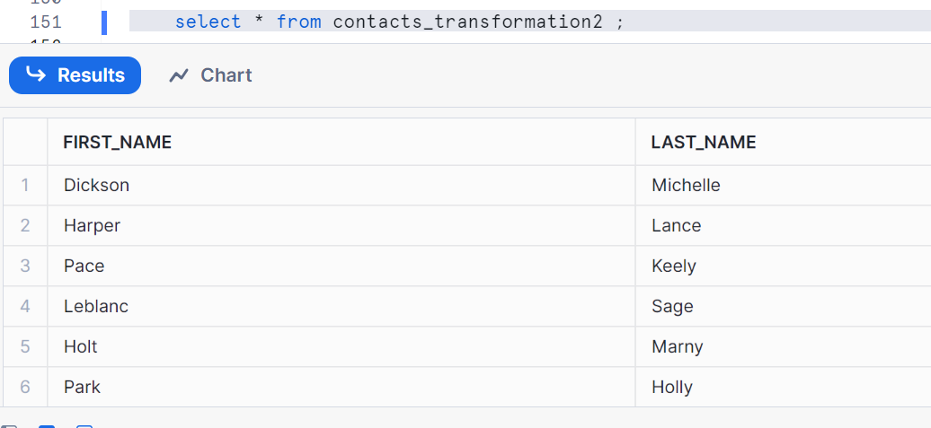
Now check contacts table with the output above

Case3: Transformation using a function
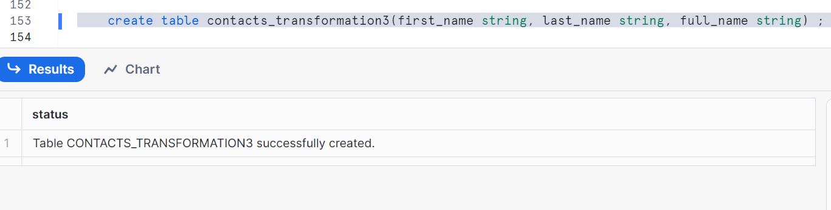
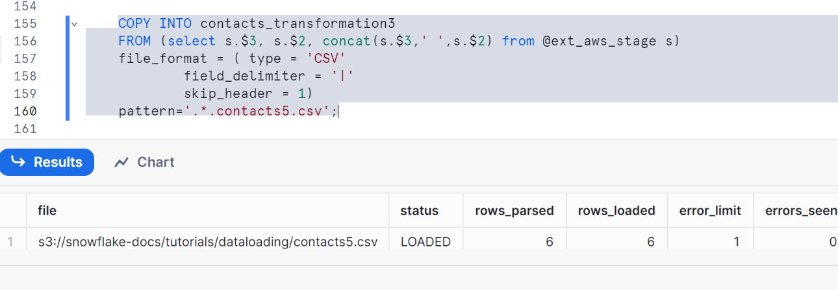
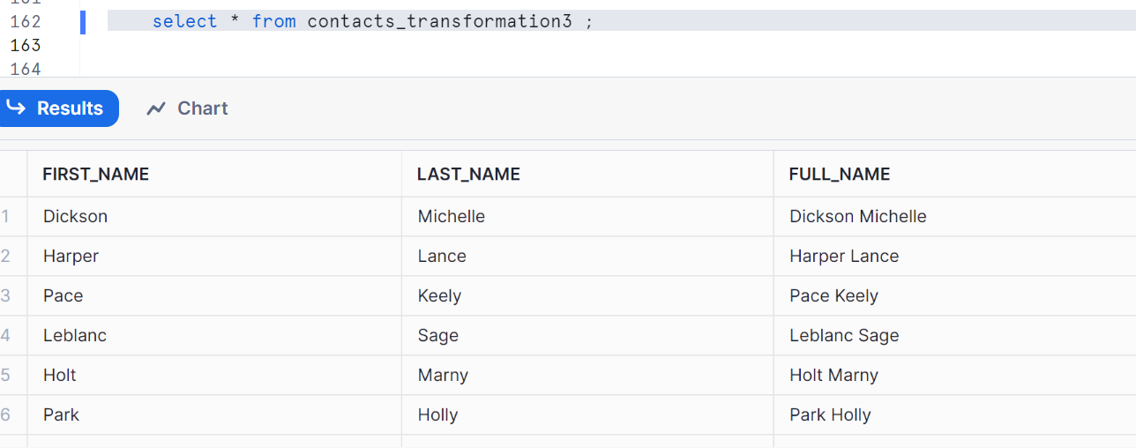
Now check contacts table with the output above

Case4: Not all functions are supported - example lower
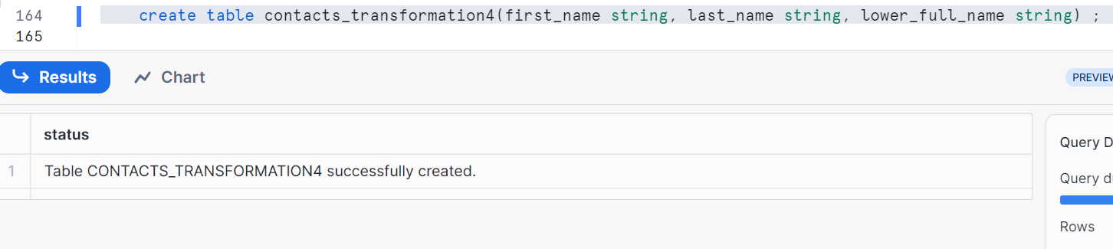
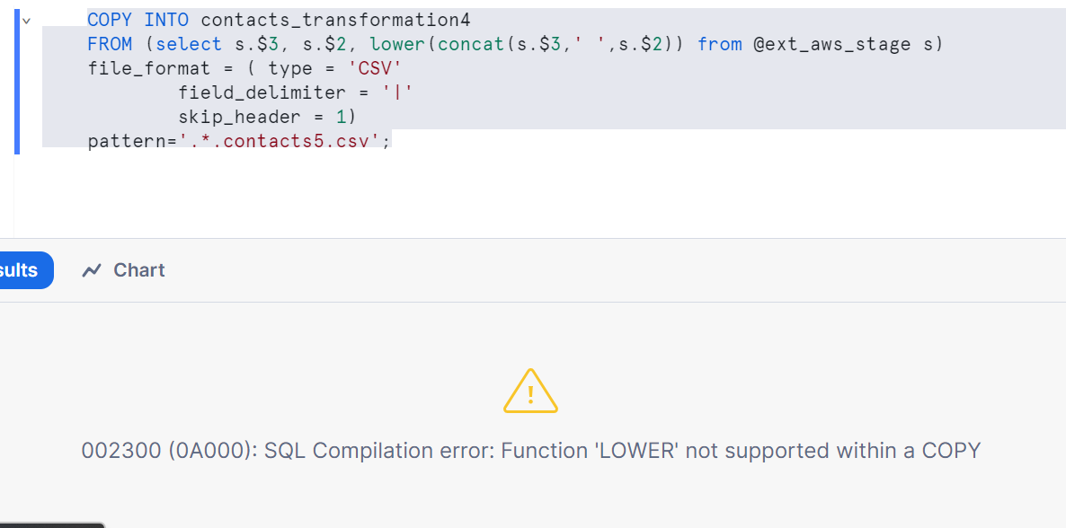
There is a specific list of transformation functions that are supported in COPY. Else you get error
I prefer you all to go to snowflake documentation for all supporting functions
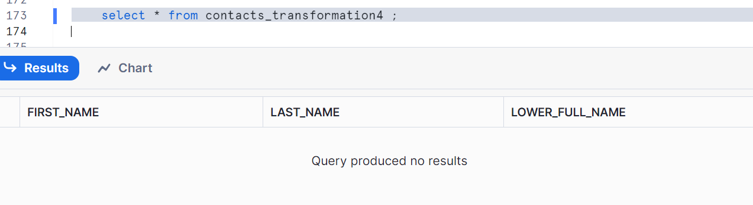
Now check contacts table with the output above

Case5: Change types
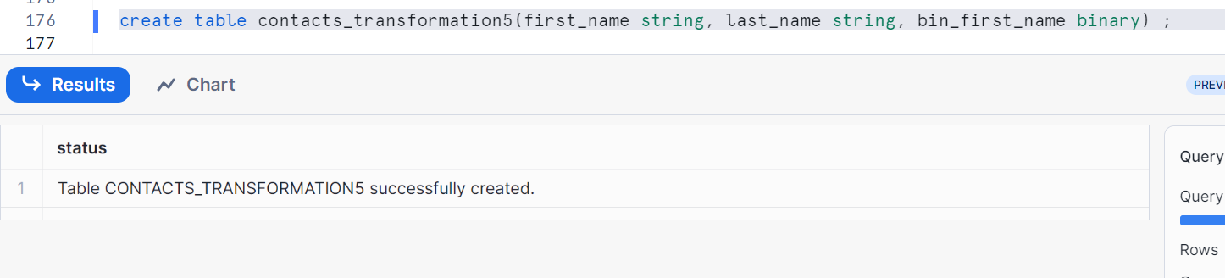
Storing the binary value of first name
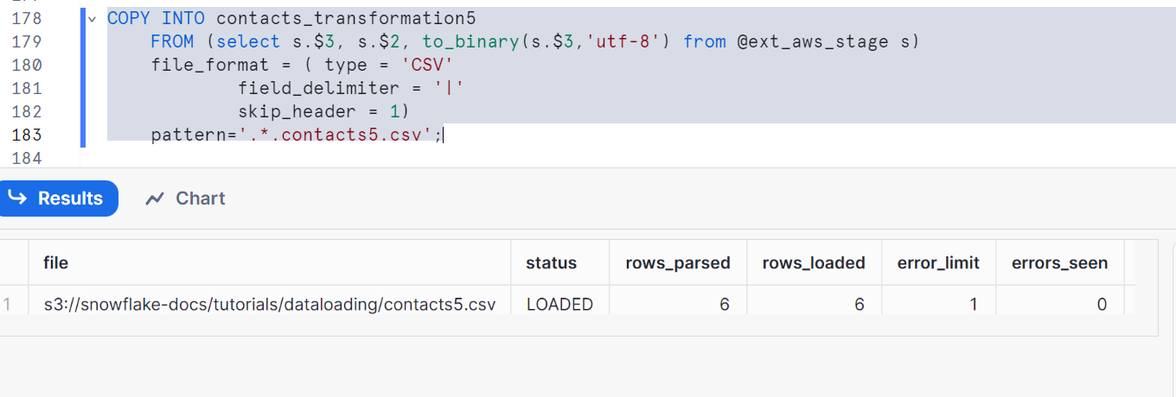
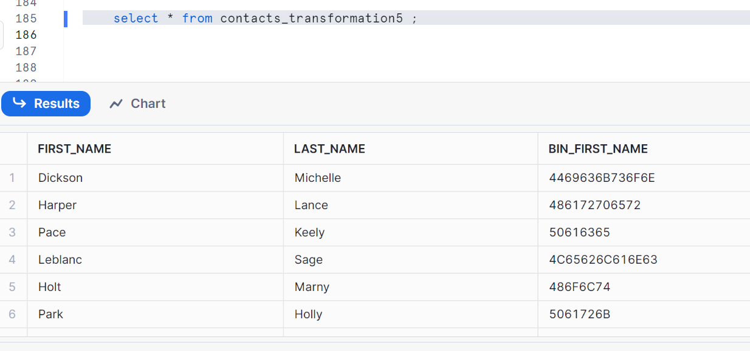
Now check contacts table with the output above

Case6: Sequence column in table
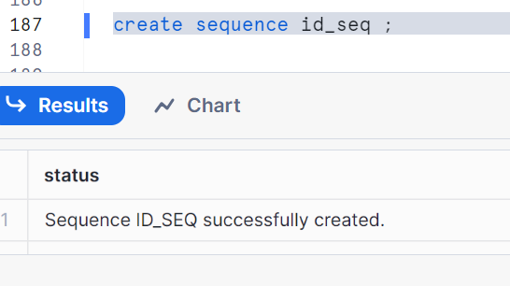
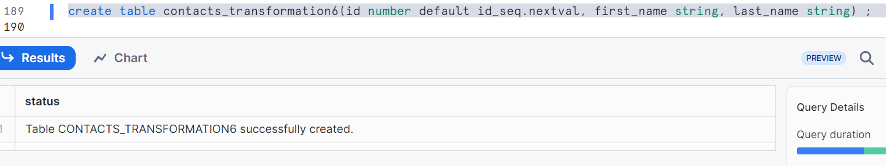
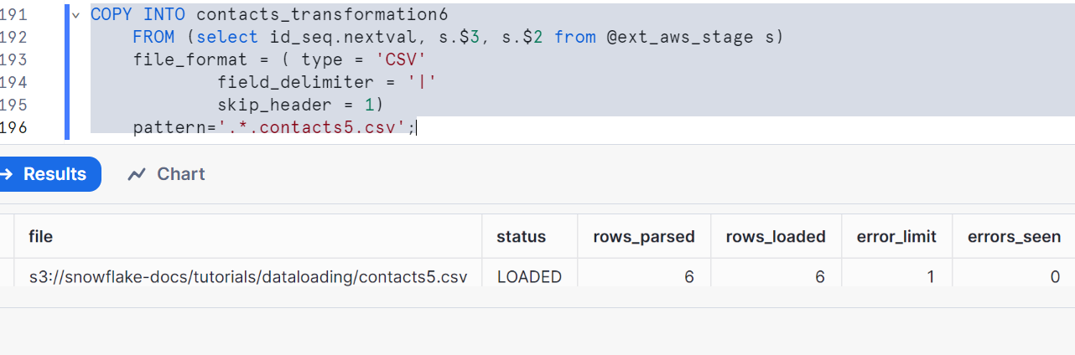
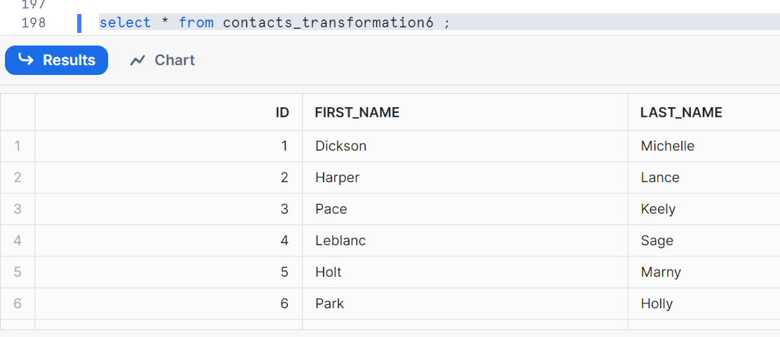
Now check contacts table with the output above

Case7: Auto increment
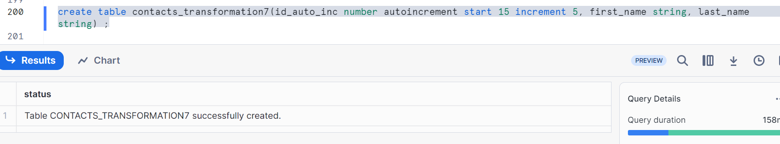
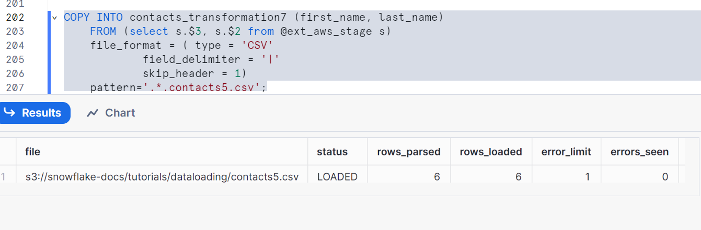
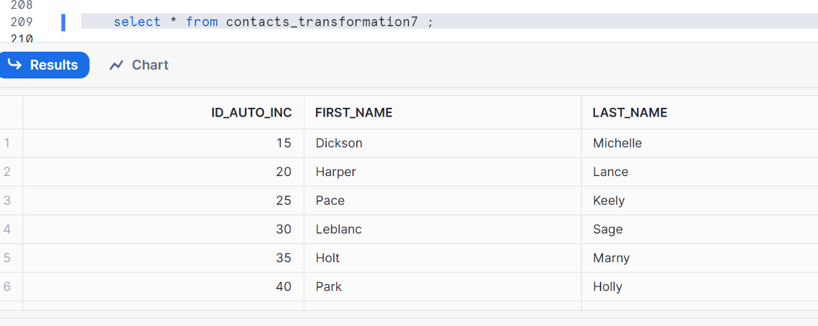
Now check contacts table with the output above
Now clean up as per the below syntax
Drop stage ext_aws_stage;
Drop table contacts;
Drop table contacts_transformation1;
Drop table contacts_transformation2;
Drop table contacts_transformation3;
Drop table contacts_transformation4;
Drop table contacts_transformation5;
Drop table contacts_transformation6;
Drop table contacts_transformation7;
Drop sequence id_seq;

